**PRACTICUM REPORT**

Job sheet 5

Selection



RIDHO ANFA’AL

2341720222

CLASS 1I (INTERNATIONAL)

INFORMATICS ENGINEERING­­

INFORMATION TECHNOLOGY

STATE POLYTECHNIC OF MALANG

**Contents**

Experiment 1 3

Experiment 2 5

Experiment 3 7

Assignment 9

**Experiment 1 :**

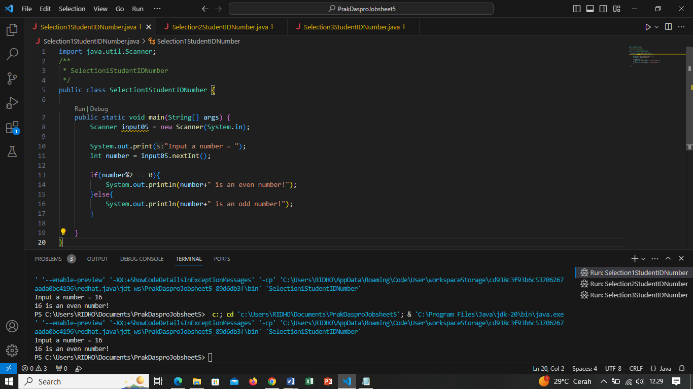

Question!

1. Modify the above selection statement (if-else) by using Ternary Operator! We know

that Ternary Operator could be used as a selection statement as well.

Answer :

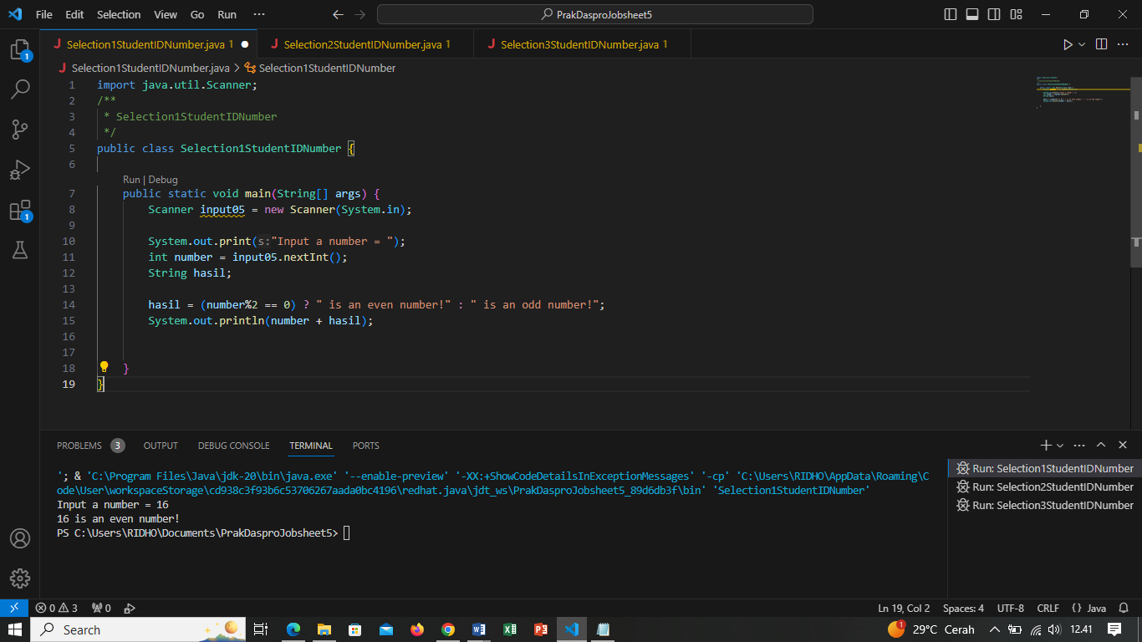

2. Compile, run and observe the result!

Answer :

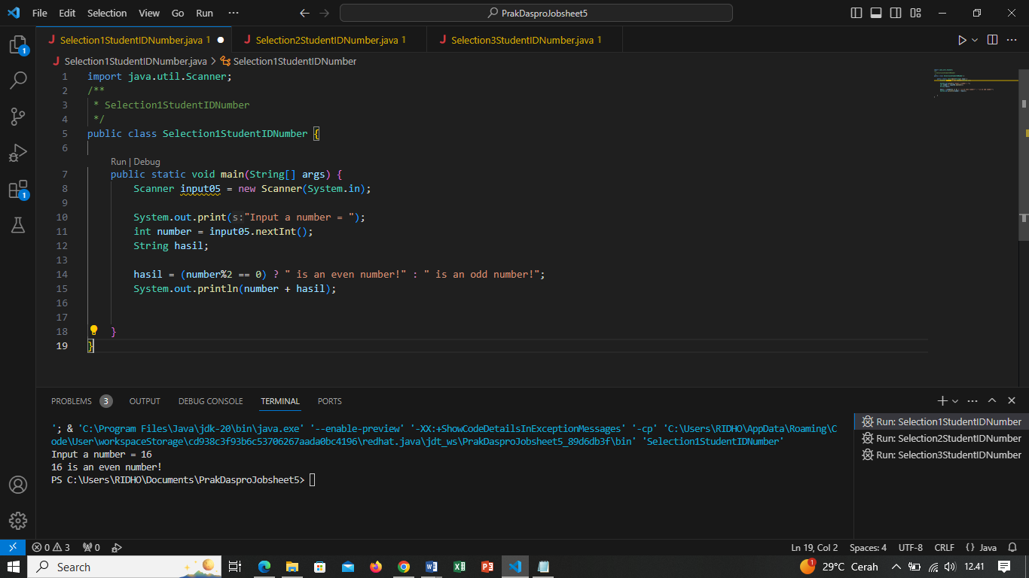

3. Commit and push the changes into your repository!

Answer : <https://github.com/RidhoAnfaal/Daspro/blob/master/Selection1StudentIDNumber.java>

4. Finally, please explain why the output of the program before and after the changes

has a similar output.

Answer : Regular selection programs and ternary operators are basically used to make decisions based on a condition. When you convert a regular selection program into a ternary operator, the result should still be the same if you write the code correctly. This is because ternary operators are just a more concise way to evaluate conditions and select values based on those conditions.

**Experiment 2 :**

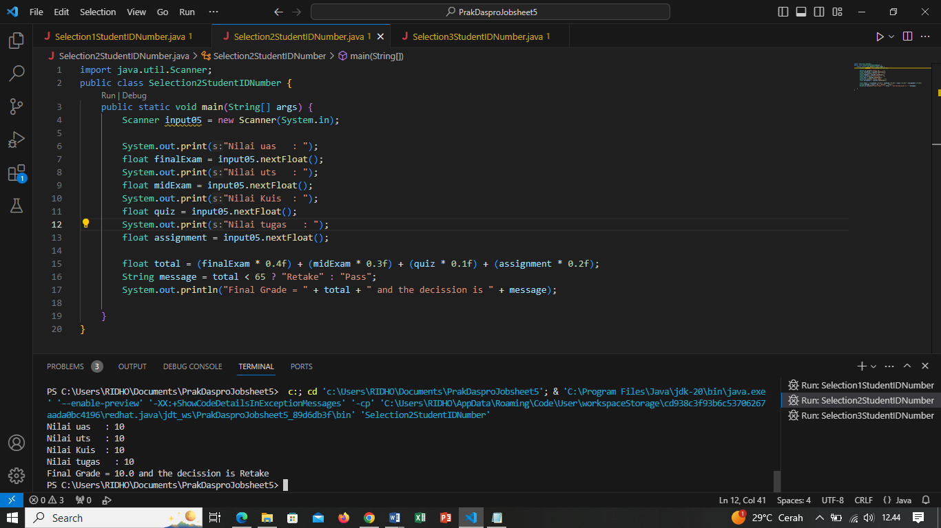

Question!

1. Modify the above program so that it now can convert from numerical grade into letter

grade, based on the following rule!

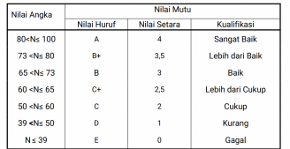

Answer : 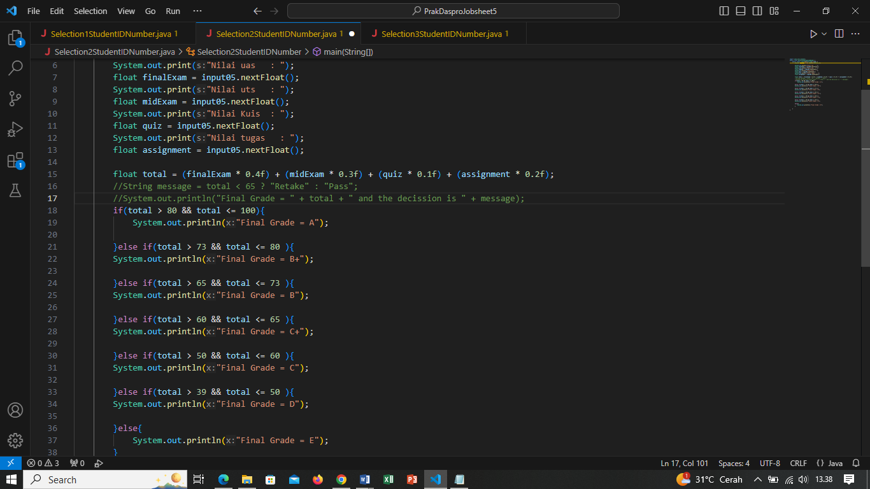

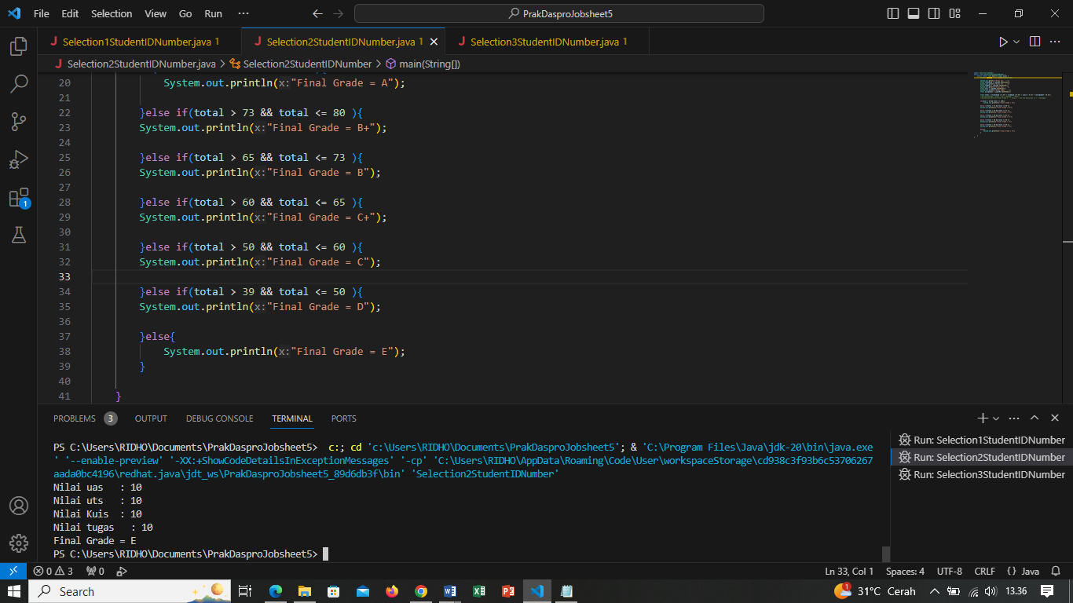

2. After the above modification, how many conditions are there and what type of

operator are used?

Answer : There are 7 conditions, if: Used to evaluate a condition, and if the condition is true, then the code block following the if will be executed. Otherwise, the code block will be skipped.

else if: Used when you have multiple conditions that you want to evaluate sequentially. If the first if condition is not met, the program will try the next else if condition. If one of the else if conditions is true, the corresponding code block will be executed.

else: Optional, but useful. The code block in else will be executed if none of the if or else if conditions are true.

**Experiment 3 :**

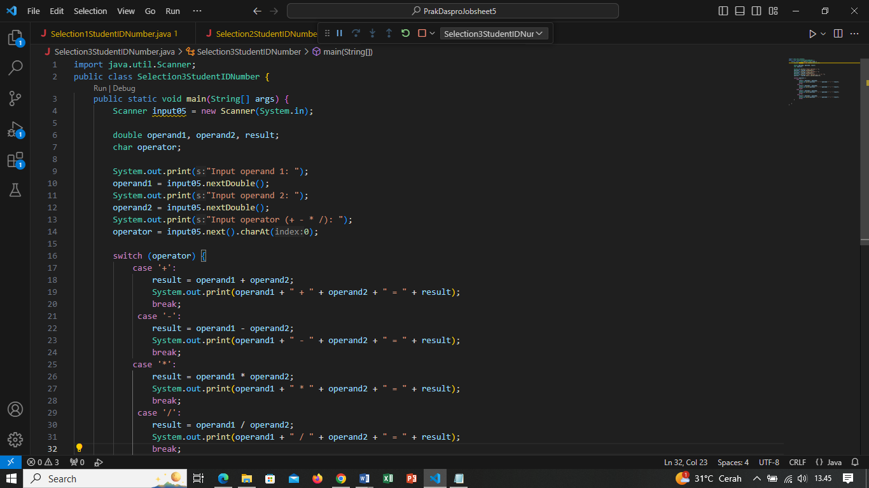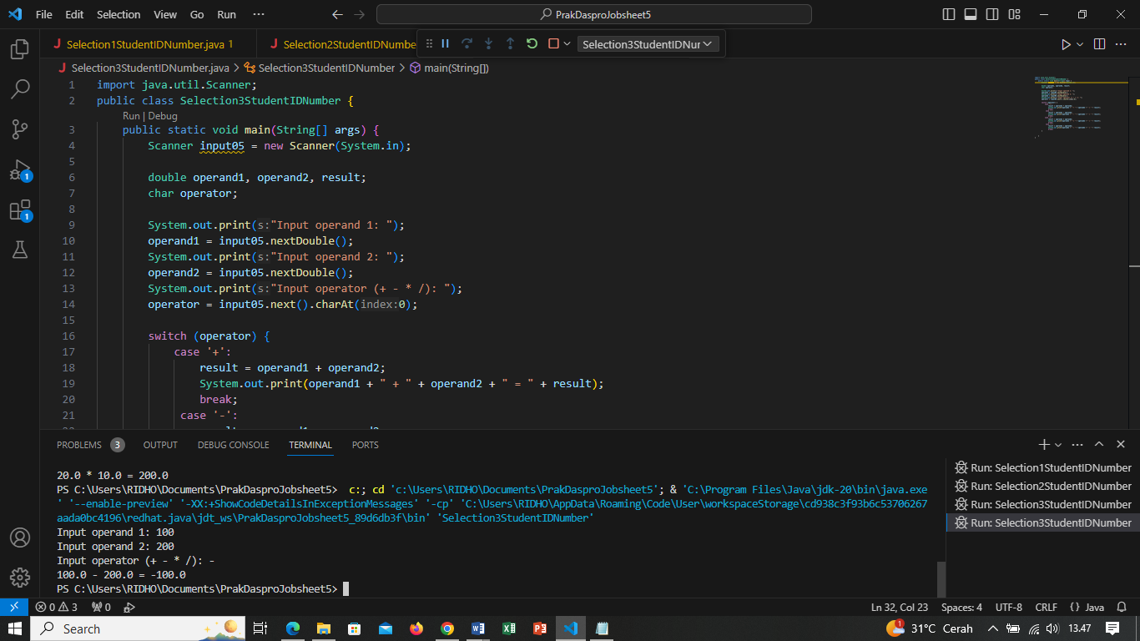

Question!

1. What is the use of break and default statement?

Answer : The break statement is used for control flow within switch statements and loops, while the default statement provides a fallback or default action to be taken when none of the specific case labels match in a switch statement.

2. Modify the above program by deleting break statement in the first case. Run the

program, observe the result, and explain what it is the effect if there is no break in

case block!

Answer : Not using a break statement in a case block can lead to fall-through behavior, where code in subsequent case blocks is executed,

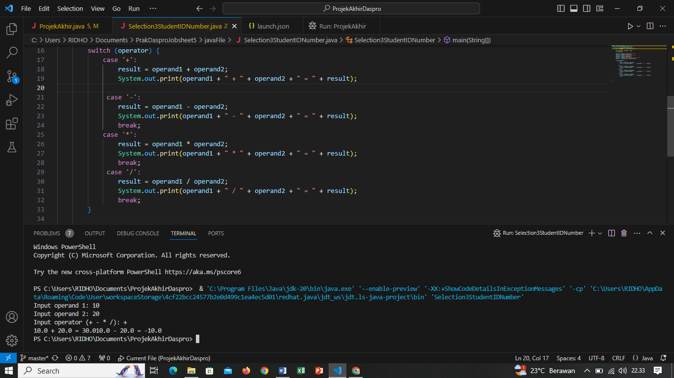

3. Commit and push the changes into your repository.

Answer : <https://github.com/RidhoAnfaal/Daspro/blob/master/Selection3StudentIDNumber.java>

4. Please explain the function of the following statement

operator = sc.next().charAt(0);

Answer : The statement operator = sc.next().charAt(0); in Java is typically used to read a character input from the user through the console using the Scanner class and assign the first character of the input to a variable named operator

**Assignment**

Create a program based on the flowchart that was already created in Assignment 5 in the Slide of Selection part 1! Commit and push the code results to your project repository!Answer : <https://github.com/RidhoAnfaal/ProjectAkhirDaspro/blob/master/ProjekAkhir.java>